SmartVision3

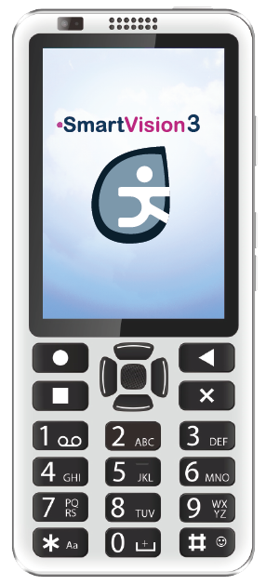
Quick starting guide

www.kapsys.com

Note
It is suggested to read the full user guide before using your SmartVision3.
An electronic version of this document is available on our website at www.kapsys.com under the Support section.
Box content
SmartVision3 is delivered with:
A 220/110 Volts mains charger – 5 Volts USB
A USB cable (C type)
A pair of stereo earphones with microphone
5 NFC tags
A SIM ejector tool
A Quick starting guide
Overview
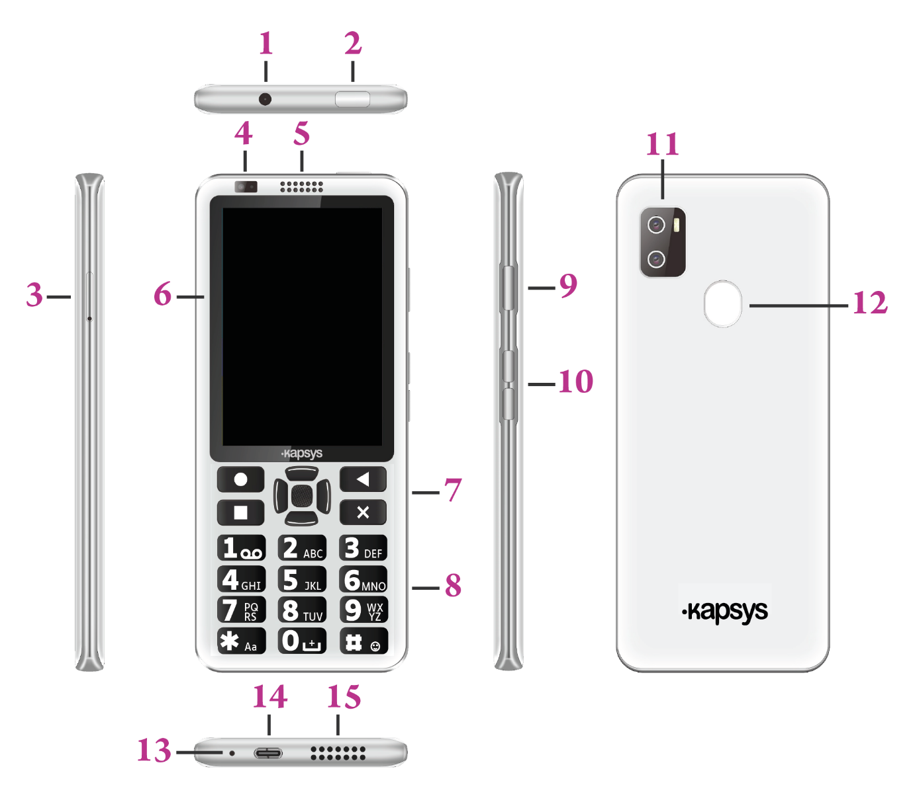

N° | Item | Description
1 | 3.5 mm headphone jack | Connect to stereo earphones
2 | Power button | Press and hold to turn SmartVision3 on/off.  Press to turn the screen on/off (sleep mode)
3 | Sim card tray | To insert your SIM and SD card
4 | Front-facing camera | Use for self-portrait images and online video chat
5 | Receiver | Main receiver for phone calls
6 | Display | Display data and control with touchscreen
7 | Control keys and  navigation pad |  | Navigate through the screen with multidirectional commands (up, down, right, left) and a central “OK” button.
 |  |  | Go back to home screen
 |  |  | Open the menu of the current screen
 |  |  | Go back to the previous screen
 |  |  | Delete user input
8 | Alphanumeric keypad | Use to input characters
9 | Voice  command button | Use to dictate text and launch specific features
10 | Volume buttons | Increase or decrease audio output level.
11 | Double rear cameras | 16 Mega Pixels + 2 Mega Pixels resolution
12 | Finger print sensor | Use to unlock the phone or make secure payments.
13 | Microphone | Main microphone for phone calls and voice recognition
14 | USB C type connector | Charge the battery /  data synchronisation
15 | Loudspeaker | Main multimedia speaker

Getting started
Inserting the Nano SIM and micro SD cards
SmartVision3 has a dual SIM / SD card connector. You can insert two SIM cards or an SD card and a SIM card. You cannot have both the second Nano SIM card and the microSD card inserted at the same time. SmartVision3 is only compatible with SIM cards in Nano SIM format. A modified card that is thicker than the standard Nano SIM card will not fit properly on the tray and may damage the SIM connector. The micro SD card is optional and is not supplied with the SmartVision3. SmartVision3 supports SD cards up to 128 GB.

- Open the SIM tray:
Lay the phone flat in front of you face up. Insert the tip of the SIM extraction tool supplied with your phone into the SIM tray eject hole on the left side of the phone. Make sure the SIM extraction tool is perpendicular to the hole. Otherwise, the device may be damaged. When inserting the SIM extraction tool into the SIM tray eject hole, do not obstruct the tray to avoid damaging the eject mechanism inside the slot. Push the tip all the way into the hole until the SIM tray pops out and then pull it out. The SIM tray has two compartments. The first compartment allows you to insert a SIM card or an SD card. The second compartment allows you to insert only a SIM card

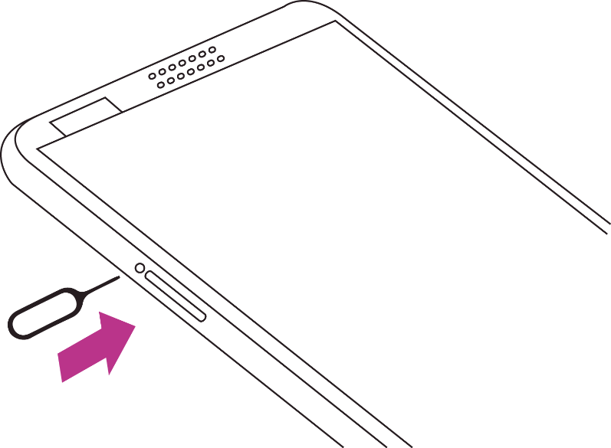

- Inserting a SIM card and a SD card (optional):
Position the SD card in the first compartment of the tray, metal side down, bevelled corner down. Then position the SIM card in the second compartment of the tray, metal side down, the bevelled corner at the bottom right. Then gently reinsert the SIM tray all the way into the slot. When reinserting the SIM tray into the phone, make sure it is oriented horizontally so that the SD card and SIM card do not fall out. The tray should be fully inserted and did not protrude from the slot.

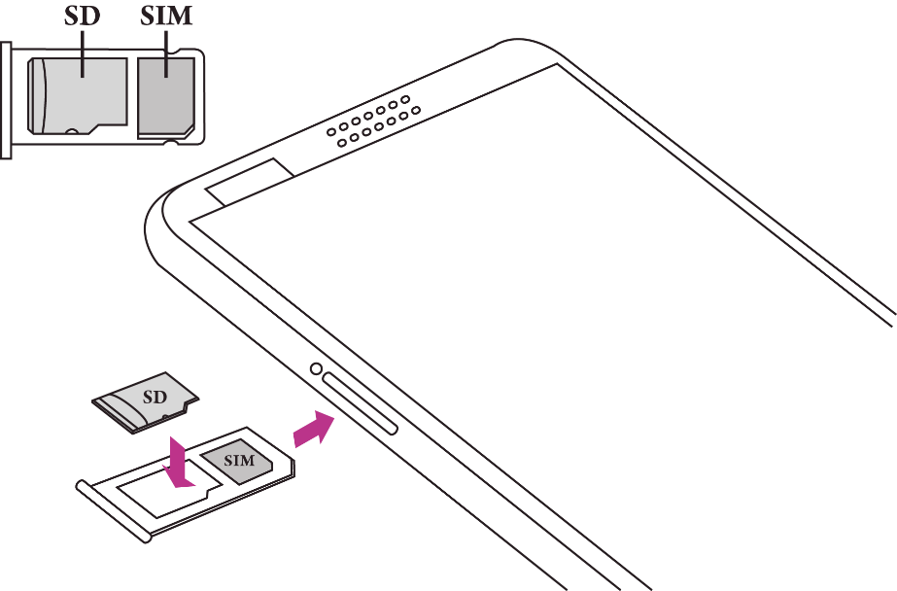

- Inserting two SIM cards:
Position the first SIM card, metal side down, bevelled corner at the bottom right, in the first compartment of the SIM tray. Perform the same operation for the second compartment of the SIM tray. Then gently reinsert the SIM tray all the way into the slot. When reinserting the SIM tray into the phone, make sure it is oriented horizontally so that the SIM cards do not fall out. The tray should be fully inserted and not protrude from the slot or fall out.
The position of the SIM cards in the tray does not matter. The SIM cards configuration and management is done via the phone's "Settings" into "Network and Internet" section.

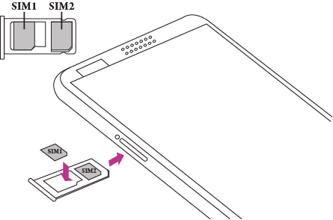

Charging the battery
Charge the battery before using the device for the first time or when you have not used it for a while. Only use a compatible charger and cable for your device. Using an incompatible charger and cable may cause injury or damage your device. To charge the battery, connect the USB Type-C cable between the SmartVision3 USB connector and the AC charger. Then plug the AC charger into a wall outlet. When the battery is fully charged, disconnect the charger from the device.

Turning your smartphone ON/OFF
To turn on your SmartVision3, press and hold the ON/OFF button located on the upper edge. When the device vibrates, release the button. If the product does not turn on, check that the battery has been properly charged.
To turn off the device, press and hold the ON/OFF button located on the upper edge. Then select on the screen the “ON/OFF” item then “Switch off”.

Restart the phone
To restart the device, make a long press on the ON/OFF button located on the upper edge. Then select on the screen the “ON/OFF” item then “Restart”. If your device freezes and becomes unresponsive, press the power button for 10 seconds to automatically restart the phone.
Standby mode
When SmartVision3 is turn ON, a short key press of the ON/OFF button will bring it to standby mode (screen off), or back to running mode (screen on). The standby mode is activated after an inactive period for battery safe.
In standby mode the screen is off and the keyboard is disabled, however the functions remain active. You can still receive your calls, messages, emails etc.
Legal notice and Warranty
1. Precautions for use and recommendations
Read all information before using the device to ensure safe and proper use.
- Handle your SmartVision3 and its accessories with care, do not drop or knock them
- Do not disassemble the product as this will void the warranty and may cause damage that may render the product unusable.
- Use manufacturer-approved chargers, data cables and other accessories to prevent potential electric shock, fire, explosion or other hazards.
- Do not dismantle the product as this will result in the warranty being voided. Back cover cannot be removed.
- Clean the product using only a soft, slightly damp cloth. Do not use chemicals, detergents or abrasive products.
- This product is not waterproof. Protect it from damp and splashes of liquids.
- Do not store your device in extremely hot or cold places. Storage temperature is -20°C to +45°.
- Do not expose your device to direct sunlight for long periods. Operating temperature range is -5°C to +40°C.
- When charging, please keep the device in well-ventilated area. Charge the mobile phone in an environment between 5°C and 35°C.
- Do not use the product near magnetic fields.
- Do not use your device if the screen is broken or cracked, as this could cause injury. If any part of the product is cracked or damaged contact your distributor.
- Do not use the product in potentially explosive areas.
- During prolonged use of your product, it may heat up. If the device overheats and reaches a certain temperature, functions and performance may be limited or the device may turn off to cool down.
- Be careful not to expose the camera lens to a strong light source, such as direct sunlight. If the lens is exposed to a strong light source, such as direct sunlight or a light beam, the camera's image sensor may be damaged. Damage to the image sensor can cause dots and spots to appear in photos.
- If dust or foreign objects get into the microphone, speaker or receiver, the sound of the device may become inaudible or some functions may not work. If you try to remove dust or foreign objects with a sharp object, you may damage the device and affect its appearance.
- Connectivity issues and battery drain may occur in the following situations:
  - If you attach metal stickers to the antenna area of the device.
  - If you install a protective case made of metallic materials on the device.
  - If you cover the antenna area of the device with your hands or other objects while using certain functions, such as calls or data connection.
- For optimal performance of your device, we recommend that you switch it off from time to time.
- The use of an approved KAPSYS screen protector is recommended. Unapproved screen protectors may cause sensors to malfunction.
- Do not use bare or damaged cables, and do not use a damaged or defective charger.

2. SAFETY AND HEALTH
- Keep the product away from small children.
- Do not use your mobile phone and adhere to all safety warnings and regulations regarding mobile device usage while driving.
- Protect your hearing: avoid prolonged exposure to high sound levels when using the earphones, loudspeakers or the receiver.
- Do not use the product in health care facilities and ask to authorized personnel before using your phone near medical equipment.
- Persons with electronic implants (pacemakers, insulin pumps, neurostimulators, etc.) are recommended to place the mobile phone 15 cm away from implant or on the opposite side of the implant.
3. WARRANTY
Your warranty is only valid under normal use of the device. All man-made damages and any of the following conditions are not covered by the warranty:
- The warranty period has expired.
- Normal wear and tear of the product (such as casing, keypad, display screen, antenna and other accessories).
- Damage resulting from improper use, exposure to humidity or liquid, or proximity to a heat source.
- Cracked or broken devices, or devices with visible signs of shocks.
- Failure to respect the precautions for use, accidents, negligence, misuse or use inconsistent with the instructions provided with the device, or commercial use of the product.
- Use of accessories or connectors not recommended by the manufacturer.
- The customer disassembles, repairs or modifies the device without the KAPSYS’ authorization or has it repaired at a repair shop that is not included in the KAPSYS’ approved repair network.
- Damage caused by a force majeure such as floods, fires, earthquakes, and lightning.
- Faults or malfunctions caused by the internet or wireless service providers (operators) are not covered by the warranty. In this case service provider will need to be contacted directly for assistance.
- A reduction in the battery charge holding capacity. During the period of warranty only a minor decrease in its capacity should occur. After this period any decrease in its capacity or loss of function is considered to be caused by a common wear.
In some out of warranty failure cases, a repair can be implemented at your own cost. In case of breakdown, please contact your dealer.
It is recommended that you perform one or more backups of the data saved in your product. KAPSYS cannot be held responsible for the loss of this data because of a malfunction, repair or replacement of the product.

4. ABOUT SPECIFIC ENERGY ABSORPTION RATE*
Your SmartVision3 by KAPSYS is a radio transmitter/receiver. It is designed and manufactured to comply with the radiofrequency (RF) exposure thresholds recommended by the European Union.
This device meets the requirements of the International Commission on Non-Ionizing Radiation Protection (ICNIRP) and European Standard for mobile radio devices.
The guidelines use a unit of measurement know as Specific Absorption Rate, or SAR. The SAR limit for mobile devices is 2.0W/kg when tested at the head or worn on the body, 4.0W/kg when worn on the limbs.
For body-worm operation, this phone has been tested use with accessories that contain no metal and that position the handset a minimum of 1.5 cm from the body. Use of other accessories may not ensure compliance with RF exposure. If you do not use a body-worm accessory and are not holding the phone at the ear, position the handset a minimum of 1.5 cm from your body when phone is switched on.
During use, the actual SAR level is usually much lower than the maximum value. In general, the closer you are to the base station, the lower the transmission output of your mobile telephone. To reduce exposure to RF energy, use a hands-free accessory or other similar option to keep the device away from your head and your body.
The highest SAR average value over 10g of body tissue of this device is listed below:
Head: 0,498 W/kg
Body: 0,765 W/kg
Limbs: 1,485 W/kg
5. Restrictions in 5GHz band
According to Article 10 of directive 2104/53/EU, the WLAN function for this device is restricted to indoor use only when operating in the 5.15 to 5.35 GHz frequency range in the following countries: AT, BE, BG, CH, CY, CZ, DE, DK, EE, EL, ES, FI, FR, HR, HU, IE, IT, IS, LV, LI, LT, LU, LV, MT, NL, NO, PL, PT, RO, SI, SE, SK, UK.
5. CUSTOMER SERVICE
For more details, please contact your dealer Customer Service or send us a mail to:
Service Clients KAPSYS – 694 avenue du Docteur Maurice Donat 06250 MOUGINS SOPHIA ANTIPOLIS, France.
You can also visit our website: www.kapsys.com.
6. TRADEMARKS
Company and product brands referred to in this document, are trademarks, either registered or not, and owned by the respective holder as follows:
KAPSYS words, brands and logos are registered trademarks of KAPSYS SAS.
Android, Google, Google Play, Chromecast built-in, YouTube and other marks and logos are trademarks of Google LLC.
Bluetooth names, brands and logos are registered trademarks of Bluetooth SIG Inc.

7. ABOUT THIS DOCUMENT
Information published in this document is liable to change without notice. KAPSYS reserves the right to amend the contents of this document with no obligation to notify any person or entity whatsoever thereof. KAPSYS cannot be held liable in the event of any technical or publishing errors or omissions contained herein, or in the event of accidental or indirect loss or damage resulting from the product operation or from using this document. KAPSYS endeavours to continuously improve our product and its features quality and performance. KAPSYS therefore invites you to visit their website (www.kapsys.com) for the latest update on the use and operation of this product.

RoHS COMPLIANCE:
This product is compliant with the 2015/863/EC Directive of European Parliament amending ROHS directive 2011/65/EU, on the use restriction of certain hazardous substances (RoHS) in electrical and electronic equipment and its amendments.

CE MARKING
This product complies with the CE marking requirements for use in residential, commercial or light industry installations, and satisfies with the provisions of the R&TTE (2014/53/EU/RED) Directive. For more information about CE marking, you can also visit our website at www.kapsys.com.

WEEE DIRECTIVE
This symbol on the product or on its packaging indicates that this product must not be disposed of with your other household waste. In accordance with the 2012/19/EU European directive on waste electric and electronic equipment (WEEE), his electrical product must not, under any circumstances, be discarded as unsorted municipal waste. Please dispose of this product by returning it to its point of sale or to your council’s local designated collection points for recycling.

CAUTION:
Permanent hearing loss may occur if earphones are used at high volume for a prolonged period of time.

