KAPX – User Manual

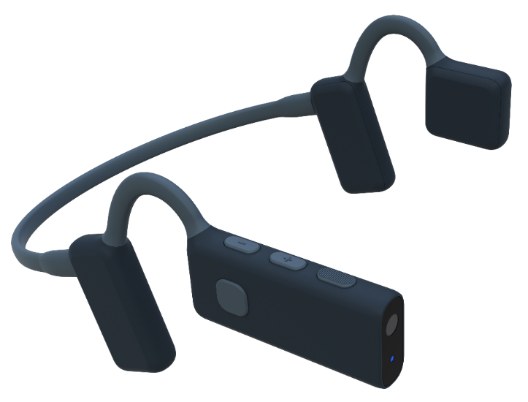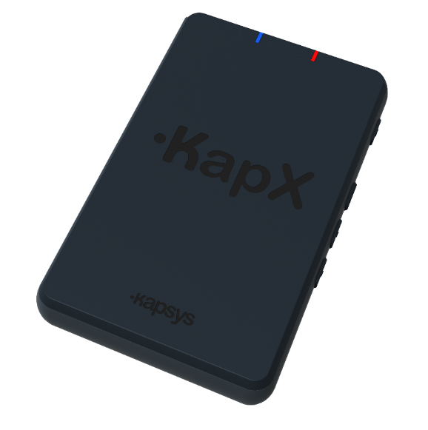

Medical Device: Class I
Applicable Regulation: (EU) 2017/745 on Medical Devices
Manufacturer: KAPSYS SAS, 694 Avenue Maurice Donat
06250 Mougins, France

Unique Device Identifier-Basic: 376017745KAPX01BQ
UDI-DI (GS1): 03760177451407
Commercial name: KapX
Catalogue reference: KAP51000

Document reference: IFU-KAPX-EN-1.9
Version: 1.9
Release date: October 2026

Table des matières
Introduction 3
Intended purpose 3
Safety instructions 4
Box contents 6
Product description 7
The headset 7
The control unit 8
Getting started and first use 9
Charging the batteries 9
Installation and start-up 9
Controls 10
Indicator lights 10
Audio indications 10
Standby mode 11
Power off 11
Functions 11
Guidance and Obstacle Avoidance 12
Environmental Description 12
Automatic Announcements 13
Search 14
Voice Commands 14
Smartphone Connectivity 15
Settings 16
Software update 17
Connecting to a home Wi-Fi network 18
Downloading the update 18
Installing the update 18
In case of problems 19
Resetting (Reset) 19
What to do in case of a problem 19
Technical Specifications 20
Legal information and support 21

Before using the device, take the time to read this document carefully.
Pay particular attention to the conditions of use as well as the safety instructions.

Introduction
KapX is a lightweight, ergonomic headset designed to improve the independence and safety of blind or visually impaired people. A true concentration of innovation, it combines artificial vision technologies with spatialized 3D sound to deliver a natural, smooth, and intuitive mobility experience.
Thanks to an onboard camera and computing unit, KapX analyzes the user’s environment in real time and conveys essential information through 3D audio (binaural sound). Spatialized sound and voice guidance make it possible to perceive the position, distance, and nature of surrounding elements, enabling freer and safer movement while maintaining full awareness of the external world.
KapX helps users identify the safest path to avoid obstacles within a ten-meter radius and instantly alerts them to nearby dangers. It also detects urban features such as pedestrian crossings, benches, or doorways, and can connect to smartphone GPS applications to combine navigation guidance with safety alerts.
All data is processed locally, ensuring information privacy and operation independent of any Internet connection. Touch and voice controls make the device simple and intuitive to use, while Bluetooth connectivity allows users to make calls, listen to music, or use their smartphone’s voice assistant without removing the headset.
Designed to integrate seamlessly into everyday life, KapX combines lightness, comfort, and durability.

Intended purpose
KapX is a Class I medical device intended to assist blind and visually impaired individuals during outdoor travel.
It provides electronic mobility assistance through obstacle detection and spatialized audio feedback.
KapX is a complementary aid and does not replace traditional mobility aids such as a white cane or guide dog

Indications
KapX is indicated for:
- Assisting the mobility of people with visual impairments
- Detecting ground-level and head-height obstacles
- Identifying urban features and infrastructure
Target population
- Adults and adolescents with partial or total visual impairment
Intended Users
- Independent users with visual impairments
- Mobility professionals (rehabilitation specialists, orientation and mobility instructors)
Contraindications
KapX must not be used:
- As the sole means of safety when crossing roads
- By individuals with severe, uncompensated hearing impairment
- While operating a motor vehicle
- In environments that are incompatible with the specified conditions of use
Expected Benefits
The use of KapX provides:
- Improved immediate environmental awareness
- Reduced risk of collisions with obstacles
- Increased mobility independence
KapX does not completely eliminate the risks associated with travel and mobility.
Required Training
No medical training is required.
For first-time use, it is recommended that the device be introduced and configured with the assistance of a mobility professional.

Safety instructions
Before using KapX, it is important to read this user manual carefully and to strictly follow certain rules to ensure your safety and maintain the proper functioning of the device.
Warnings and Conditions of Use
The guidance and obstacle-avoidance device for visually impaired people (hereinafter referred to as “KapX”) is an electronic mobility aid. It is designed to complement the user’s sensory abilities during movement, but in no way replaces their vigilance, their assessment of the environment, or the use of traditional aids (such as a white cane or a guide dog).
Safety and Proper Use
- Use KapX only in accordance with the instructions in the user manual.
- Check that it is in proper working condition before each use.
- Do not use KapX in extreme conditions (heavy rain, dense fog, snow, very bright or very low light, noisy environments, etc.) that may affect sensor accuracy.
- Always remain attentive to your surroundings, especially when crossing roads or in crowded areas.
Performance Limitations
- The KapX product relies on sensors and data-processing algorithms that may have margins of error.
- Some obstacles may not be detected, may be incorrectly assessed, or may be reported with a slight delay.
- Performance may vary depending on the environment, weather conditions, or terrain configuration.
User Confidentiality and Data Privacy
- All images and video data acquired by the integrated camera are processed exclusively on the device. No image, video, or derived data is transmitted to external servers, web services, or cloud-based platforms for processing or analysis. The device performs all image processing functions locally using its embedded hardware and software. Consequently, an active Internet connection is not required for normal operation of the image processing features. This architecture helps preserve the confidentiality of patient and user data by limiting data processing to the device itself.
- Because of the headset's “open-ear” design, the sound can be heard by people nearby, especially when the headset volume is set to a level higher than 10 out of 15. To minimize audio leakage and maintain user privacy, use the lowest volume that provides adequate speech intelligibility, especially when using the device in public or shared environments. Users should be aware that confidential or sensitive information played through the headset may be overheard by others.
Residual Risks
Despite the risk control and mitigation measures implemented during the design and development of KapX, the following residual risks may remain:
- Failure to detect an obstacle
- Delayed obstacle detection
- Misinterpretation of an audio signal
- Unexpected electronic malfunction
- Electromagnetic interference
- Skin reactions resulting from prolonged contact with device materials
Liability
The manufacturer and the distributor of KapX disclaim all liability in the event of:
- Accidents, injuries, or damage resulting from improper or negligent use.
- Unauthorized modification of the hardware or software.
- Use of non-approved parts or accessories.
The user remains solely responsible for their own safety and for assessing risks during their movements.
Use of KapX implies full and unconditional acceptance of these terms and conditions.
Weather Conditions
To ensure optimal operation, it is recommended not to use KapX in heavy rain, snow, dense fog, or at night. These conditions may limit sensor accuracy and reduce the reliability of the information provided.
Temperature Range
KapX operates properly within a temperature range of -20°C to +55°C. Using it outside these limits may impair performance or damage its components.
Water Resistance
This headset is rated IP54, meaning it is resistant only to light splashes. It must not be immersed or exposed to heavy rain.
Sensor Protection
To ensure optimal detection, it is important not to cover, soil, or obstruct KapX’s sensors. Any obstruction may prevent the device from properly detecting obstacles or terrain.
User Comfort and Health
If using KapX causes pain, prolonged discomfort, or noticeable irritation, it is recommended to stop using it immediately and check the fit or condition of the device before resuming use.
Transport and Storage
When not in use, store KapX in its protective case or in a dry, dust-free place. Avoid exposing it to extreme temperatures or high humidity during transport or storage to preserve its sensors and electronic components.

Box contents
When you open your KapX package, you will find everything you need to start using your headset with ease:
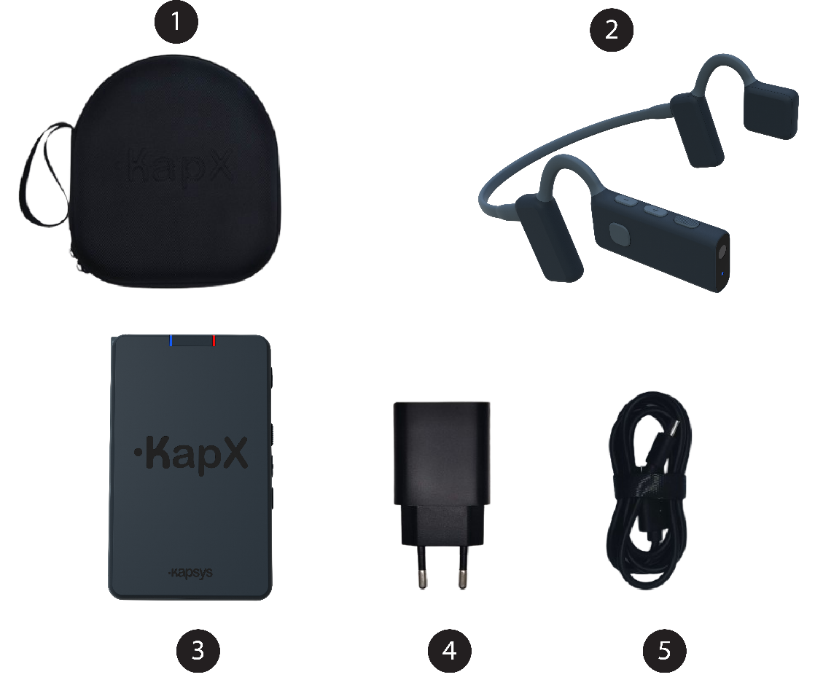
- A carrying case designed to hold the headset and the control unit.
- The headset.
- The control unit.
- A UBS-C wall charger.
- A USB-C cable.
Note: the power delivered by the charger must be between min 5 Watts required by the radio equipment, and max 20 Watts in order to achieve the maximum charging speed.

Product description
The KapX product consists of two inseparable components: the headset and the control unit. The headset is equipped with a camera and various sensors. The data collected by these sensors is transmitted wirelessly to the control unit, where it is processed to perform the product’s various functions (guidance, description, alerts, etc.).

The headset
The KapX headset is designed as a lightweight, ergonomic neckband, intended to rest comfortably on the ears. It features two open-ear speakers that deliver guidance information without blocking the ear canal, allowing external sounds to remain clearly audible.
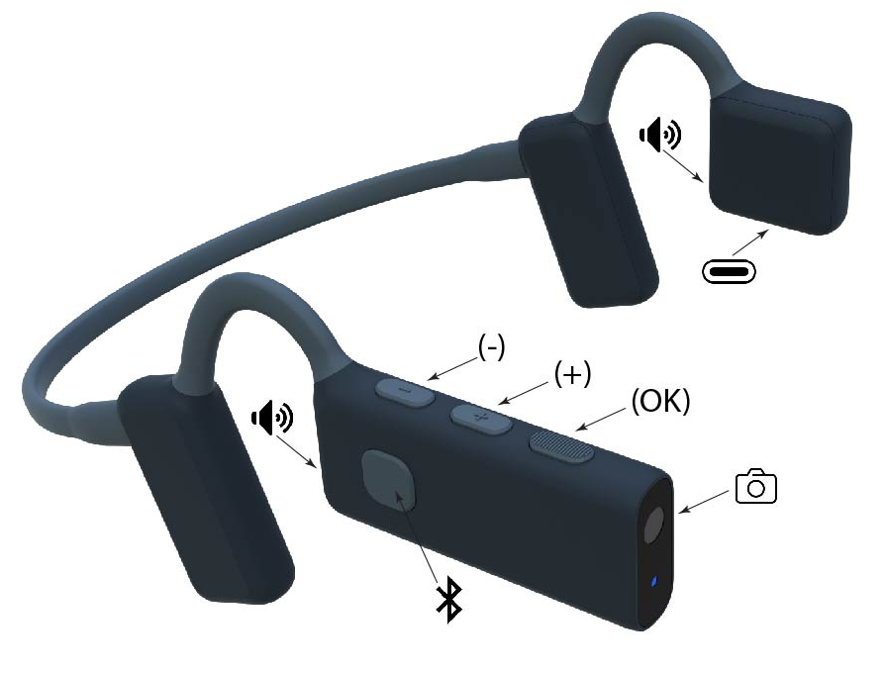
The right arm includes:
- A front-facing camera.
- A status indicator light located just below the camera, indicating the headset’s operating status (power on, battery level, etc.).
- Three physical buttons located along the top edge (described from front to back):
- The “OK” button at the front (textured for easy identification).
- The “Plus” button in the center.
- The “Minus” button at the rear (closest to the ear).
- A Bluetooth control button located on the outer side, used to manage calls, music, or voice assistant.
- The right speaker directed toward the ear.
The left arm includes:
- A USB-C charging connector located on the lower edge.
- The left speaker directed toward the ear.

The control unit
The KapX control unit is designed as a small rectangular module. Compact in size, it can be held in the hand, stored in a pocket or bag, or attached to a belt. It connects wirelessly to the headset and is responsible for processing the information collected by the sensors.
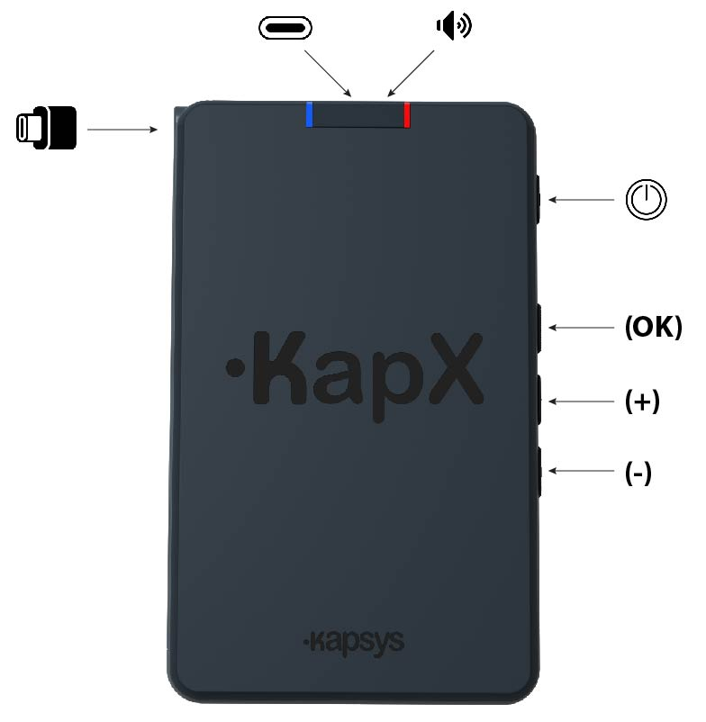
The top surface includes:
- A raised “KapX” marking that makes it easy to orient the control unit.
- A built-in speaker at the top, providing audio feedback when the headset is not connected.
- A blue indicator light showing the operating status of the control unit.
- A red indicator light showing the battery status of the control unit.
On the right side are four vertically aligned control buttons (described from top to bottom):
- The “Power” button (top).
- The “OK” button (textured for easy identification).
- The “Plus” button.
- The “Minus” button (bottom).
The left side features a USB-C cable equipped with a pull tab for easy removal from its storage slot. This cable is used exclusively to charge the KapX headset.
The upper edge includes a USB-C connector dedicated solely to charging the control unit using the charger supplied with the product.

Getting started and first use

Charging the batteries
Before using KapX for the first time, it is recommended to fully charge both the control unit and the headset. A full charge takes approximately 2 hours and provides optimal use for about 2 hours.
- Remove the integrated USB-C cable from the control unit and connect the headset to its USB-C port located on the lower edge of the left arm.
- Then connect the USB-C charger with its supplied cable to the control unit.
- Plug the charger into a wall outlet.
A voice message will notify you when the battery level of the headset or the control unit is low (below 10%).
Note: when the control unit battery is charged to 100%, it can recharge the headset at least twice without any external power source.

Installation and start-up
- Position the headset on your head
Hold the headset with both hands, with the headband facing backward. Place the headband behind your head and position the speakers in front of your ears, directly on your temples. Your ears remain free and uncovered. Adjust the position so that the right side, which integrates the camera, is as horizontal as possible. Check that the headset fits securely; it should not slip during normal head movements. Whenever possible, it is recommended not to wear glasses for better comfort and to avoid obstructing part of the camera’s field of view.
- Turn on the headset
Press and hold the “Minus” button on the headset for 3 seconds, then release it. A welcome sound will confirm that the headset has powered on.
- Turn on the control unit
Press and hold the “Power” button on the control unit for 3 seconds, then release it. A welcome sound will also confirm that the control unit has powered on.
- Connect the headset to the control unit
Wait a few seconds for the headset to automatically connect to the control unit. An audio signal from the headset will confirm that the connection is active.
- Adjust the volume
Use the “Plus” and “Minus” buttons on the headset or on the control unit to adjust the volume to your preference, depending on the surrounding noise level.
KapX is now operational, and you can follow its guidance instructions.
While moving, it is recommended to keep your head upright and aligned with your body to ensure accurate guidance. If the headset or head position is not correct, a voice alert will inform you.

Controls
The headset and the control unit each feature three buttons, “Plus,” “Minus,” and “OK, which allow you to control and configure the various KapX functions via the management interface.
By default, when the system is operating in guidance mode, the three control buttons perform the following actions:
- “Plus” button: increases the volume.
- “Minus” button: decreases the volume.
- “OK” button: opens the KapX management interface.
- Long press (3 seconds) on “OK”: activates voice command.
- Short press on “Power” button: announces the battery level.
When the KapX management interface is active, the three control buttons perform the following actions:
- “Plus” button: selects the next item in the list.
- “Minus” button: selects the previous item in the list.
- “OK” button: confirms the selected item.
- Quick double-click on “OK”: goes back to the previous menu.
- Short press on “Power” button: announces the battery level.
Each action performed using these buttons is followed by a clear voice confirmation for the user.
Warning: Activating the management interface suspends guidance

Indicator lights
The indicator lights on the headset and the electronic unit show the operating status of the product (Blue LED) as well as the battery status (Red LED):
- Slow flashing blue: indicates that the product is powered on and operational.
- Fast flashing blue: indicates that the product is not operational. Either the headset and the unit are not connected, or the headset is in standby mode.
- Flashing red: indicates that the battery level is low (<10%).
- Solid red: indicates that the battery is charging.

Audio indications
By default, KapX uses three-dimensional spatialized sound (called binaural sound) to indicate guidance orientation or the orientation of an object. Binaural sound uses two distinct audio signals sent to each ear, creating a spatial perception of direction. This technology allows the user to mentally locate obstacles, directions, or points of interest thanks to the difference in sound perceived between the left ear and the right ear.
For guidance, a binaural sound is generated in the direction the user should follow. If no sound is played, this indicates that the space ahead is free of obstacles or dangerous traffic routes.
For environmental descriptions as well as announcements, binaural sound makes it possible to mentally locate the direction or orientation of the detected object.
If users have difficulty perceiving and interpreting binaural sounds, it is possible in the KapX settings to switch to a clock-based indication, using the analogy of a clock to indicate direction. For example, 12 o’clock straight ahead, 1 o’clock slightly to the right, or 9 o’clock far to the left.

Standby mode
KapX automatically enters standby mode when the headset is not worn.
During standby, all guidance, description, and announcement functions are paused.
As soon as the headset is placed back on the user’s head, KapX instantly reactivates and resumes normal operation.

Power off
You can turn off the control unit and the headset separately, however turning off the control unit will also automatically turn off the headset.
Turning off the control unit: Press and hold the control unit’s “Power” button for 3 seconds, then release it. A shutdown sound will confirm that it has turned off.
Turning off the headset: Press and hold the headset’s “Minus” button for 3 seconds, then release it. A shutdown sound will confirm that it has turned off.
Automatic shutdown: The headset will automatically turn in standby mode when it is not being worn on the head.

Functions
KapX offers several essential functions to help blind or visually impaired people navigate and move safely:
- Guidance and obstacle avoidance.
- Environmental description.
- Automatic announcements.
- Search
- Voice commands.
- Smartphone connectivity.

Guidance and Obstacle Avoidance
Guidance and obstacle avoidance are the main functions of KapX. Thanks to its camera and various sensors, KapX analyzes the environment in front of you in real time, detecting the safest pathways as well as obstacles on the ground and at head height within a 10-meter radius.
The guidance function can be paused from the management interface or via voice command.
- Briefly press the “OK” button to enter the management interface and pause guidance.
- From the list, select the “Path finder” function and confirm with “OK”.
- Then select the type of description you want from the three options and confirm with “OK”.
Obstacle Avoidance
When an obstacle is detected in front of you, KapX calculates the best detour route to avoid it, using the safest pedestrian pathways. A spatialized guidance sound is then played in the headset to indicate the path and the direction to follow.
If no guidance sound is played, this indicates that the space ahead is free of danger.
Guidance
KapX will keep you on, and guide you along, the safest path of movement based on the detected environment, helping you avoid hazardous areas such as bike lanes, roads, and railway tracks.
An alert message will inform you if KapX is unable to keep you within a safe walking area in order to avoid an obstacle, for example when approaching a pedestrian crossing, a road, a bike lane, or railway tracks. This alert will indicate the type of surface you may need to use with caution if you choose to proceed (pedestrian crossing, bike lane, or railway tracks).
This warning can be disabled in the KapX settings.
Emergency Stop
In the event of a nearby danger within a configurable detection range of 1 to 3 meters, KapX issues a clear voice alert indicating the type of obstacle detected. This alert takes priority and interrupts all other information (guidance, announcements, Bluetooth). In this situation, it is necessary to stop immediately and search for a free area by slowly turning around until the alert stops.

Description
The Description function allows KapX, upon user request, to describe the environment in front of them within a 10-meter radius.
KapX then analyzes the latest camera capture and verbally announces all detected elements from left to right, specifying their distance and orientation.
Activating Description function
- Briefly press the “OK” button to enter the management interface and pause guidance.
- From the list, select the “Description” function and confirm with “OK”.
- Then select the type of description you want from the three options and confirm with “OK”.
Environmental Description: a general description of the surrounding environment, such as sidewalk, street, parking lot, pedestrian crossing, etc.
Urban Elements Description: a detailed description of urban elements around you, such as bus stops, traffic lights, poles, building doors, pedestrians, vehicles, etc.
Terrain Description: a detailed description of different types of terrain and pathways around you, such as sidewalks, pedestrian crossings, trails, bike lanes, roads, etc.
Voice description information is overlaid on the guidance sound.
The description function can also be activated directly via voice command.

Automatic Announcements
Similar to the Description function, this feature automatically announces terrains and urban elements as soon as they appear within the camera’s field of view, up to a 10-meter radius, without any action required from the user when the function is active.
The voice announcement specifies the type of urban element or terrain detected, its distance, and its orientation. This information is overlaid on any guidance instructions.
By default, this function is not activated, the user must enable it manually from the management interface.
Activating and Configuring Automatic Announcements
- Briefly press the “OK” button to enter the management interface and pause guidance.
- From the list, select the Automatic announcements” function and confirm with “OK” to enter the configuration menu.
- Select “Activated” and confirm with “OK” to enable (or disable) the function.
- Select “Objects to_announce” and confirm with “OK” to choose which objects you want to announce from the proposed list. Double-click “OK” to return to the previous menu.
- Select “Announcement Frequency” and confirm with “OK” to choose how often announcements are repeated from the following options: every 3, 5, or 10 seconds.
Double-click “OK” to return to the previous menu.
- Double-click “OK” to exit the management interface and resume guidance.
Activating or deactivating this function, as well as selecting which objects to announce, can also be done via voice command.

Search
With this function, you can ask KapX to search for a specific item from the available list. As soon as KapX identifies it within a 10-meter radius, it will announce its distance and direction. This announcement is made only once; if you want to reactivate it, you will need to enable it again individually.
Activating the Search Function
- Press the “OK” button briefly to enter the management interface and pause the guidance.
- Select the “Search” function from the list and confirm with “OK” to enter the function configuration menu.
- Select the Object to search for from the proposed list and confirm with “OK.” KapX will then return to guidance mode and start searching for the selected object.
This function can also be activated using a voice command.

Voice Commands
KapX features a simplified voice recognition system that allows you to control the main functions without using manual controls. This functionality is designed for smooth and accessible use at any time, even while navigating the management interface.
Activating Voice Recognition
To activate voice recognition, press and hold the “OK” button for three seconds, then release it.
A voice prompt will invite you to speak your command after the sound signal.
Then, clearly state your command in a complete sentence.
Each recognized command is confirmed by a voice message indicating the action performed or the system status.
If a voice command is not recognized, KapX will inform you and prompt you to repeat your request.
Example of Available Voice Commands
“What is the battery level? ”: Reports the battery level of the headset and control unit.
“Please activate guidance”: Activates the guidance and obstacle avoidance function.
“Stop the guidance mode”: Deactivates the guidance and obstacle avoidance function.
“Describe the urban elements around me”: Initiates a description of urban elements.
“Give me a description of the terrain nearby”: Initiates a description of terrains.
“Give me a description of my environment”: Initiates a description of the environment.
“Turn announcements on”: Activates the automatic announcement function.
“Please deactivate announcements”: Deactivates the automatic announcement function.
“Activate notifications for pedestrians”: Selects the object pedestrian to announce automatically.
“Deactivate notifications for pedestrian crossing”: Deselects the object or type of terrain to announce automatically.
“Try to find nearby building doors “: Activates the search for an object or a type of terrain.

Smartphone Connectivity
The KapX headset can connect to your smartphone via Bluetooth, allowing access to standard Bluetooth functions such as making calls, using your navigation app, listening to music, using your assistant (Siri, Google Assistant, Gemini), or receiving audio feedback from your phone’s accessibility features (TalkBack or VoiceOver).
Connecting to a Smartphone
To use your headset fully, you must pair it with your smartphone via Bluetooth for the first time. This simple operation only needs to be done once, unless you change devices.
- Enable Bluetooth on your smartphone.
- Open your phone’s Settings.
- Select the Bluetooth menu.
- Turn on Bluetooth if it is off.
- Put the headset in pairing mode.
- Turn on the headset.
- Briefly press the “OK” button to enter the management interface and pause guidance.
- From the list, select “Settings” and confirm with “OK”.
- Select “Smartphone Connection” and confirm with “OK”.
- Select “Bluetooth On” and confirm with “OK” to activate the headset’s Bluetooth if it is off.
- Select “Connect a new smartphone” and confirm with “OK” to activate the headset’s pairing mode.
3. Pair the headset with your smartphone
- On your smartphone, wait for the headset to appear in the list of available devices.
- Select the headset name: KapX followed by its serial number.
- Confirm the pairing request if a confirmation message appears.
Once pairing is successful, the headset emits a sound signal and your smartphone displays the device as Connected.
Bluetooth Control from the Headset
The KapX headset has a dedicated button for controlling your smartphone’s Bluetooth functions. It is located on the outer side of the right arm of the headset. When the headset is connected to a smartphone, the functions are as follows:
- Single click: Accept a call, end a call, or play/pause music.
- Double click: Reject a call or skip to the next track.
- Triple click: Return to the previous track.
- Long press (3 seconds): Activate the smartphone’s voice assistant.
The headset’s volume is adjusted directly from the smartphone.
In the event of danger, KapX automatically interrupts the smartphone audio stream to issue the priority emergency stop message.

Settings
The Settings menu in the management interface allows you to precisely configure KapX’s functions.
The available options are:
Smartphone Connection:
- Bluetooth enabled: allows KapX Bluetooth to be enabled or disabled. (Bluetooth is disabled by default).
- Connect a new smartphone: allows the previous pairing to be removed and authorizes pairing with a new smartphone. (No active pairing by default on first use).
Emergency stop distance: allows the analysis distance for the emergency stop to be set (1 meter, 1.5 meters, 2 meters, 2.5 meters and 3 meters).
Warning_dangerous_surfaces: Allows you to disable the warning when approaching dangerous areas (pedestrian crossings, cycle paths, roads, or railway tracks). It is strongly recommended to keep this option enabled. Disabling this function removes an essential safety feature of KapX. By disabling it, the user agrees to use KapX under their sole responsibility. KAPSYS cannot be held responsible for any incidents, damage, or injuries resulting from improper use or from the voluntary deactivation of safety alerts.
Avoid pedestrians: When this option is enabled, pedestrians are treated as obstacles and KapX will guide you by avoiding them. By default, this option is disabled, so KapX will not attempt to avoid them.
Announcement type: allows customization of guidance and announcement cues:
- 3D sound:announces directional information using binaural sound (3D sound in space). (Enabled by default).
- Time indication: announces directional information using clock-face references.
3D sound: allows customization of the 3D guidance sound from several available options.
Language and Voices: allows customization of KapX’s audio feedback.
- Language: allows changing the product language. Available languages may vary depending on the software version.
- Voice selection: allows changing the product voice (male or female). Please note that some languages may offer a limited number of available voices.
- Voice speed: allows setting the speech rate from 6 available speeds: very slow, slow, normal, fast, faster, very fast.
Distance unit: allows customization of the units used (meters or feet).
About KapX: allows viewing product information or restoring default settings.
Software update: allows managing KapX software updates (headset and control unit).
Tutorial: Allows you to adjust the left/right balance of your headset and become familiar with the guidance system and 3D audio.

Software update
To check whether an update is available, the KapX control unit must be connected to your home Wi-Fi network with Internet access. KapX cannot connect to public networks, such as those in train stations or hotels, that require additional authentication.
Once the connection is established, KapX will check for available updates, automatically start downloading them, and guide you through the installation process.

Connecting to a home Wi-Fi network
- Briefly press the “OK” button to enter the management interface and pause guidance.
- Select “Settings” from the list and confirm with “OK”.
- Select “Software update” from the list and confirm with “OK”.
- Select “Wi-Fi” and confirm with “OK” to enable Wi-Fi on the control unit.
- The next step is to connect KapX to your home Wi-Fi network using one of the following three options:
  - Connection by manual password entry:
Select “Scan networks” from the list, then select the name of your home network from the available networks. Next, manually enter the password using the KapX buttons:
    - The “+” button selects the next letter.
    - The “–” button selects the previous letter.
    - The “OK” button confirms the selected letter.
To change the input mode (Lowercase / Uppercase / Numeric), press the “OK” key three times quickly.
To validate the password, press the “OK” button again.
  - Connection via QR code:
Select “Scan QR code”, then position your Wi-Fi network’s connection QR code in front of the headset camera to initiate the connection.
  - Connection via text file:
Beforehand, create a text file named “wifi.txt” containing:
    - On the first line: your network name (SSID)
    - On the second line: the Wi-Fi password
Save this file to the root directory of the control unit’s memory using a USB connection to your computer.
Then select “Connect via text file” to initiate the Wi-Fi connection.

Downloading the update
As soon as the control unit has access to the Internet, it will check whether an update is available and, if necessary, ask you to confirm its download. The download will then run in the background, and KapX will remain operational during this phase.
To access the headset update, the headset must be turned on and connected to the control unit.

Installing the update
When the control unit starts up, KapX will inform you that an update is available and will ask you to confirm its installation.
You should then follow the vocal instructions to proceed with the installation. At the end of the process, KapX will restart automatically.

In case of problems

Resetting (Reset)
In the event of a malfunction, freezing, or abnormal behavior, KapX can be reset. Resetting fully restarts the system without erasing the saved settings. Press and hold the control unit’s “Power” button for 10 seconds. A sound will be played when the unit restarts.

What to do in case of a problem
Why does the device not turn on?
- The battery may be depleted. Recharge the device using the supplied cable for at least 10 minutes.
- The power button may not have been held long enough. Press and hold the power button for 3 seconds.
- A temporary malfunction may have occurred. Restart the device by holding the power button for 10 seconds.
Why is the device not charging?
- The cable or adapter may be faulty. Use the cable and adapter provided with the device.
- The charging port may be dirty or obstructed. Check and carefully clean the USB-C charging port.
Why is the battery life shorter than expected?
- The device may be used intensively. Fully recharge the battery.
- Some features may be enabled unnecessarily. Disable unused features such as Wi-Fi and Bluetooth.
- The battery may be aging. Contact your reseller’s technical support.
Why is there no sound coming from the device?
- The volume may be set to the minimum level. Increase the volume.
- The speaker may be obstructed. Check that the speaker grills are clean.
Why does the device not detect obstacles correctly?
- The sensors may be obstructed. Clean the camera lens with a soft cloth.
- The device may not be positioned correctly. Check that the device is properly worn or oriented.
- Environmental conditions may be difficult. Try using the device in a more open environment.
Why does the headset not connect to the unit?
- The headset may not be turned on. Turn it on by pressing and holding the headset’s volume down button for 3 seconds.
- The distance between the headset and the unit may be too great. Move them closer together (less than 5 meters).
- A software malfunction may have occurred. Turn on both the headset and the unit, then connect the headset to the unit using the USB-C cable.
Why does the device not connect to my smartphone?
- Bluetooth may be disabled on the smartphone. Enable Bluetooth.
- The devices may be too far apart. Move them closer together (less than 5 meters).
- The device may already be paired with another device. Remove the device and pair it again.
Why is the device not responding?
- A software malfunction may have occurred. Restart the device by holding the power button for 10 seconds.
- The software may not be up to date. Check if updates are available.

Technical Specifications
Item | Value
Weight | Headset: 60 g  Control Unit: 200 g
Speaker | Headset: open-ear stereo speakers  Control Unit: mono 1 W
Battery life | Headset: 2 h / Case: 4 h
Connectivity | Bluetooth 5.2
Protection | IP54
Charger | Input: 110–220 V / 50–60 Hz  Output: 5–9 V / 2 A / USB-C (20W)
USB Cable | USB-C connectors

Legal information and support
  - Website: www.kapsys.com
  - Email: support@kapsys.com
  - Phone: +33 (0)4 92 28 88 88
  - Address: KAPSYS SAS, 694 Avenue Maurice Donat, 06250 Mougins, France.
  - Class I Medical Device in accordance with Regulation (EU) 2017/745 on medical devices.
  - The Unique Device Identifier (UDI) is displayed on the product label.
Precautions and Warnings
- Handle your KapX product and accessories with care. Avoid drops and heavy impacts.
- Do not disassemble the product. Any attempt to do so may void the warranty and cause irreversible damage.
- Clean the headset, control unit, and sensors only with a soft, clean, dry cloth. Do not use chemicals, detergents, or abrasive products.
- KapX is rated IP54 and resistant only to light splashes. Never immerse it or expose it to heavy rain.
- Do not use your product near a heat source or store it in a hot, humid, or corrosive environment.
- Do not use your product near strong magnetic fields.
- Do not use your product if any component is cracked, broken, or damaged.
- Do not use your product in explosive atmospheres.
- Do not use your product in healthcare facilities without authorization from qualified personnel, especially near medical equipment.
- Do not charge your product at temperatures below 0°C or above 45°C.
- Your product contains Lithium-Ion batteries. To optimize battery lifespan, perform regular full charges.
- Operating temperature: -20°C to +55°C.
- Short-term storage temperature: -20°C to +60°C.
- Long-term storage temperature: -10°C to +25°C.
- During prolonged use, the headset and control unit may become slightly warm.
- For optimal performance, regularly turn off your product when not in use.
- Ensure the camera and sensors are never obstructed to guarantee optimal detection.
- Keep your product out of reach of young children.
- Protect your hearing: prolonged listening at high volume may damage hearing.
- If you wear a medical implant or pacemaker, consult your physician or implant manufacturer before use.
- Radio transmission equipment may interfere with insufficiently protected medical devices.
- Always remain attentive to your surroundings during movement, especially in crowded areas or when crossing roads.
Warranty
In case of malfunction, please contact your reseller or KAPSYS support.
No warranty is granted in the following cases:
- Normal product wear or reduced battery performance.
- Damage caused by improper use, humidity, exposure to liquids, or heat sources.
- Cracked, broken products or products showing visible signs of impact.
- Failure to follow precautions or improper use.
- Use of accessories, chargers, or connectors not recommended by the manufacturer.
- Repairs or repair attempts carried out by unauthorized persons.
- Unauthorized hardware or software modifications.
Electromagnetic Field (RF) Exposure
KapX contains Bluetooth® and Wi-Fi radio transmitters operating at low power. The device has been evaluated for compliance with applicable human exposure limits for radio frequency electromagnetic fields and complies with EN 50663 and EN 62479. The device is intended to be worn as described in this manual. No special precautions regarding RF exposure are required during normal use.
Customer Service
or more information, contact KAPSYS Customer Service:
KAPSYS 694 avenue Maurice Donat 06250 Mougins – France
Website: www.kapsys.com Email: support@kapsys.com Phone: +33 (0)8 97 65 25 00
Trademarks
Company and product names mentioned in this document are registered or unregistered trademarks belonging to their respective owners.
The names, trademarks, and logos KAPSYS and KapX are registered trademarks of KAPSYS.
The names, trademarks, and logos Bluetooth are registered trademarks of Bluetooth SIG Inc.
All other products or service names are trademarks belonging to their respective owners.
About this document
The information published in this document may be modified without prior notice. KAPSYS reserves the right to modify the content of this document without obligation to notify any person or organization.
KAPSYS declines all responsibility for technical errors, omissions, or indirect damages resulting from the use of the product or this document.
KAPSYS continuously improves the functions and performance of its products. Regularly consult KAPSYS Website to obtain the latest updates and documentation
Reporting a Serious Incident
Any serious incident occurring in relation to the device must be reported to:
Manufacturer: support@kapsys.com
A serious incident means any event that has led, or might have led, to:
- Death
- Serious deterioration of a person's health
- A serious public health threat
Symbols Used
The symbols displayed on the product labels comply with ISO 15223-1
Symbol | Meaning | Standard | Location
 | Conformity with MDR | EU 2017/745 | Device Label / Packaging Label / IFU
 | UK Conformity Assessed marking | UK MDR 2002 | Device Label / Packaging Label / IFU
 | Indicates manufacturer | ISO 15223-1 | Packaging Label / IFU/ Device Label
 | Date of Manufacturing | ISO 15223-1 | Packaging Label
 | Unique Device Identifier | EU MDR 2017/745 | Packaging Label / IFU
 | Catalogue reference | ISO 15223-1 | Packaging Label / IFU
 | Warning | ISO 15223-1 | Packaging Label / IFU
 | Consult instructions for use | ISO 15223-1 | Packaging Label / IFU
 | Serial Number | ISO 15223-1 | Device Label / Packaging Label
 | Limit of temperature | ISO 15223-1 | Packaging Label / IFU
 | Medical Device | ISO 15223-1 | Packaging Label / IFU
 | Crossed-out wheeled bin – Dispose of according to EU WEEE Directive | EU WEEE Directive | Device Label /Packaging Label
 | Recovery/recycling symbol – Indicates that the product or its components can be recycled | ISO 7000 | Packaging Label
 | Class II equipment – Indicates double insulated equipment (no protective earth required) | IEC 60417 | Packaging Label / Wall charger Label
 | RoHS | EU RoHS Directive 2011/65/EU | Packaging Label
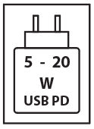 | USB Power Delivery charging input | USB Power Delivery Specification (USB-IF) | Packaging Label
 | Caution, avoid listening at high volume levels for long periods | IEC 60417-6044 | Packaging Label

